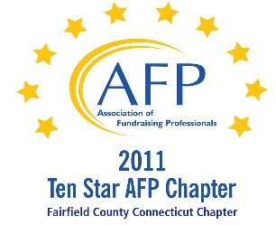

AFP Audio/Web Conference

Transformational Gifts: Using Philanthropic Planning To Partner with Prospects and Advisors

Our AFP Chapter is happy to make Web Conferences available for our fundraising community. We purchase the Web Conference from AFP International to ensure quality programs and present them at a central location. This is not a webinar, all conference participants watch the presentation at the identified location.

Registered participants will receive an email the day prior to the conference, with a link to download their own conference materials. (There will be no handouts given at the conference.)

FREE TO AFP MEMBERS ($20 for non-members*)

Presenter:
Brian M. Sagrestano, JD, CFRE

Date:
January 24, 2013 (Thursday)
Start Time:
1:00 PM

Estimated Length:
1 hour, 30 minutes

Location:
Fairfield County Community Foundation
383 Main Avenue, Norwalk, CT
Tel 203.750.3200 (reception)
Contact: Elaine Mintz - 203.750.3209

Directions:
Please park on level P2 or P1 (the last 2 levels of the parking garage). You will enter the building through the elevator lobby and take the elevator to Plaza Level to sign in. The Community Foundation is on the 4th floor.

Fairfield County Community Foundation is located in the Merritt View building, 383 Main Ave., Norwalk. The major landmark is a large shopping center directly across the street, with a Bob's Stores and Stop and Shop.

Registration/Payment:
Free to AFP Members; $20 for Non-Members*

*We ask that payment for Non-Members be made in advance, either by mailing a check made payable to “AFP-FC” and mailed to:

Marianne Hickey, 29 Black Alder Lane, Wilton, CT 06897

or we can accept a Visa or M/C payment over the phone by calling Marianne at 203.834.1910.

To confirm your attendance, send an email to: mshickey@optonline.net

About the Event:

For the last forty years, charities have focused their high-end fundraising on unrestricted gifts from the Traditionalist generations (born Pre-1946). With the rise of the "New Philanthropists" (born 1946-present), there has been a significant generational shift in the donor base. In this session, Brian will share the latest research from his book with co-author Robert E. Wahlers, The Philanthropic Planning Companion: The Fundraisers' and Professional Advisors' Guide to Charitable Gift Planning, exploring why charities and professional advisors must use a collaborative, philanthropic planning approach when working with high net worth donors from these rising New Philanthropists. Special attention will be given to the common elements from philanthropic planning efforts from Princeton, Harvard, the Heritage Institute and others.

At the conclusion of this session, participants will:
- Understand the shared values of different generational cohorts and what motivates their giving
- Understand the opportunities for their practice/organization if they embrace a philanthropic planning approach for high net worth prospects/clients
- Identify the best practices for shaping a practice or charitable organization to work with high net worth individuals in philanthropic planning
Target Audience
Advanced Level presentation. It will apply the information on generational cohorts to principal gifts/high net worth prospects.
CFRE Credits:
You earn 1.5 CFRE credits toward certification for each Audio/Web Conference you attend. For more information about CFRE certification, please visit http://www.afpnet.org/Professional/CertificationList.cfm?navItemNumber=554

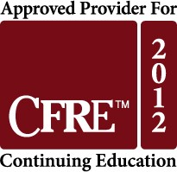

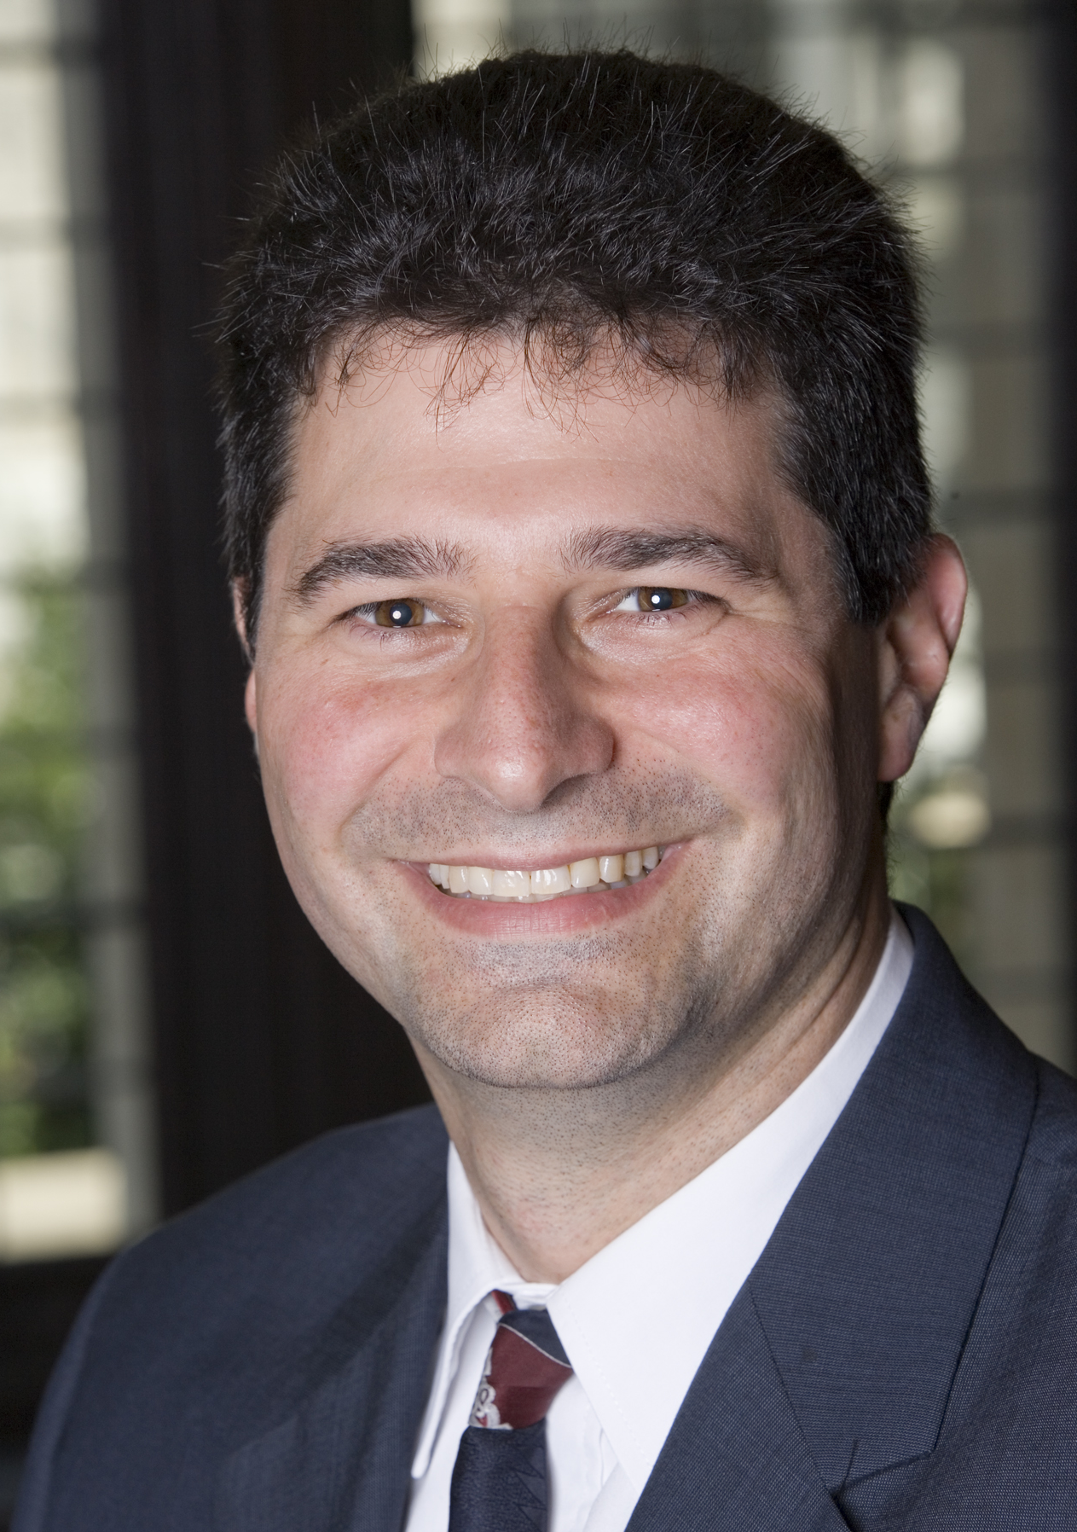
About the Presenter:
Brian M. Sagrestano, JD, CFRE is the Founder of Gift Planning Development, a gift planning consulting firm, and co-author of the Philanthropic Planning Companion: The Fundraisers' and Professional Advisors' Guide to Charitable Gift Planning. He is a nationally recognized speaker on gift planning topics, having presented multiple times at the AFP International Conference on Fundraising, the National Conference on Philanthropic Planning, the American Council on Gift Annuities Conference, the Crescendo Practical Planned Giving Conference and many regional and local events.

