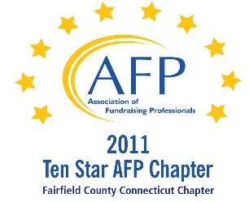

AFP Web/Audio Conference

The Planned Giving Toolbox

Our AFP Chapter is happy to make Web Conferences available for our fundraising community. We purchase the Web Conference from AFP International to ensure quality programs and present them at a central location. This is not a webinar, all conference participants watch the presentation at the identified location.

Registered participants will receive an email the day prior to the conference, with a link to download their own conference materials. (There will be no handouts given at the conference.)

FREE TO AFP MEMBERS ($20 for non-members*)

Presenter:
Greg Hammond, CFP, CPA

Date:
October 23, 2012 (Tuesday)

Start Time:
1:00 PM

Estimated Length:
1 hour, 30 minutes

Location:

Fairfield Prep, Fairfield University Campus
1073 North Benson Road, Fairfield, CT 06824-5157
First floor of Xavier Hall, President’s Conference Room (across the hall from Xavier 112)
Contact: Larry Carroll
Phone: 203-254-4237

Directions:
Please see below

PLEASE NOTE: Attendees need to enter and exit the building through Prep’s main entrance (at the far end of the parking lot) and must report to the main office to be signed in, so allow some extra time.

Registration/Payment:
Free to AFP Members; $20 for Non-Members

*We ask that payment for Non-Members be made in advance, either by mailing a check made payable to “AFP-FC” and mailed to:

Marianne Hickey, 29 Black Alder Lane, Wilton, CT 06897

or we can accept a Visa or M/C payment over the phone by calling Marianne at 203.834.1910.

To confirm your attendance, send an email to: MarianneHickey@afpfairfield.org

About the Event:

The Planned Giving Toolbox is a detailed training discussion illustrated with case studies that will provide a simple introduction or refresher of traditional and non-traditional planned giving tools and strategies to address the needs and concerns of your donors. This presentation will break down planned giving vehicles, often viewed as "too complex," to provide you the confidence and ability to generate more immediate gift and planned giving opportunities with your donors. We will discuss how various charitable planning strategies can provide donors with lifetime retirement income while creating larger inheritances to heirs and legacies to the non-profits they care about. This presentation will include Tax Advantaged Gifts, the IRS IRA Gift Matching Program, Donor Advised Funds, Uncommon Charitable Uses of Commercial Annuities, Charitable Remainder Trusts, Enhanced Charitable Trusts, Tax-Free Wealth Replacement Plans and much more. The Planned Giving Toolbox will also equip you with suggestions for increasing planned giving opportunities.
In this session:
- Advantages of addressing donor concerns and needs with planned giving strategies
- Details of specific traditional and non-traditional planned giving tools and strategies through case studies
- Suggestions for communicating planned giving opportunities to donors
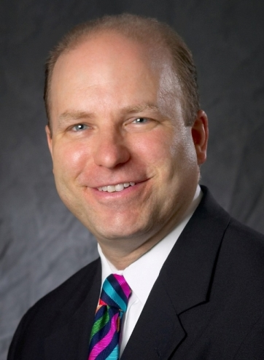
Target Audience
From beginner to experienced, the Planned Giving Toolbox will provide development professionals a simple introduction or a detailed refresher to donor-centric traditional and non-traditional planned giving tools and strategies.
About the Presenter:
With over 20 years in the financial services industry, Greg Hammond, a CERTIFIED FINANCIAL PLANNER™ Professional and Certified Public Accountant, has counseled hundreds of individuals and families on drastically reducing their taxes, preserving wealth, increasing net worth, charitable and estate planning, and building a legacy. Greg regularly facilitates educational sessions to help individuals, families, and business owners, for 3 years co-hosted the radio show, "Planning for Tomorrow" on WTIC News Talk 1080AM, and has spoken throughout New England on planned giving at the AFP CT Philanthropy Day, various AFP Chapters, and The Planned Giving Group of CT.

DIRECTIONS TO FAIRFIELD PREP

Fairfield Prep, Fairfield University Campus
1073 North Benson Road, Fairfield, CT 06824-5157
First floor of Xavier Hall, President’s Conference Room (across the hall from Xavier 112)
Contact: Larry Carroll
Phone: 203-254-4237

PLEASE NOTE: Attendees need to enter and exit the building through Prep’s main entrance (at the far end of the parking lot) and must report to the main office to be signed in, so allow some extra time.

From New York Via Connecticut Turnpike: Take exit 22 (Round Hill Road). Take a left onto Round Hill Road. Turn right onto Barlow Road. At the traffic light turn left onto North Benson Road. Turn left into the Fairfield University main entrance (Loyola Drive). Prep consists of the four-building complex on your left. VISITORS’ PARKING: From Loyola Drive, take a left onto McInnes Road (the turn onto McInnes Road is the first left after the guard house). Take your next left onto Murphy Road. Take your next left into the Prep main parking lot. Visitors’ parking spaces are located on the far side of the parking lot.

From New Haven Via The Connecticut Turnpike: Take exit 22 (North Benson Road). Turn right onto North Benson Road. Proceed through two traffic lights. Turn left into the Fairfield University main entrance (Loyola Drive). Prep consists of the four-building complex on your left. VISITORS’ PARKING: From Loyola Drive, take a left onto McInnes Road (the turn onto McInnes Road is the first left after the guard house). Take your next left onto Murphy Road. Take your next left into the Prep main parking lot. Visitors’ parking spaces are located on the far side of the parking lot.

Via the Merritt Parkway: Take exit 44 (Fairfield Business District). Follow Route 58 south onto Stillson Road (Route 135). Bear left onto North Benson Road. Turn right into the Fairfield University main entrance (Loyola Drive). Prep consists of the four-building complex on your left. VISITORS’ PARKING: From Loyola Drive, take a left onto McInnes Road (the turn onto McInnes Road is the first left after the guard house). Take your next left onto Murphy Road. Take your next left into the Prep main parking lot. Visitors’ parking spaces are located on the far side of the parking lot.

First floor of Xavier Hall, President’s Conference Room (across the hall from Xavier 112)

