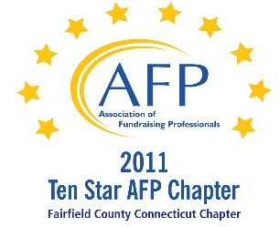

AFP Web/Audio Conference

Building a Major Gifts Pipeline Despite BIG Obstacles

Our AFP Chapter is happy to make Web Conferences available for our fundraising community. We purchase the Web Conference from AFP International to ensure quality programs and present them at a central location. This is not a webinar, all conference participants watch the presentation at the identified location.

Registered participants will receive an email the day prior to the conference, with a link to download their own conference materials. (There will be no handouts given at the conference.)

FREE TO AFP MEMBERS ($20 for non-members*)

Presenter:
Adrienne Capps

Date:
September 13, 2012 (Thursday)
Start Time:
1:00 PM

Estimated Length:
1 hour, 30 minutes

Location:
Fairfield County Community Foundation
383 Main Avenue, Norwalk, CT
Tel 203.750.3200 (reception)
Contact: Sharon L. Reiss, CFRE - 203.750.3205

Directions:
Please park on level P2 or P1 (the last 2 levels of the parking garage). You will enter the building through the elevator lobby and take the elevator to Plaza Level to sign in. The Community Foundation is on the 4th floor.

Fairfield County Community Foundation is located in the Merritt View building, 383 Main Ave., Norwalk. The major landmark is a large shopping center directly across the street, with a Bob's Stores and Stop and Shop. Driving directions are attached.

Registration/Payment:
Free to AFP Members; $20 for Non-Members

*We ask that payment for Non-Members be made in advance, either by mailing a check made payable to “AFP-FC” and mailed to:

Marianne Hickey, 29 Black Alder Lane, Wilton, CT 06897

or we can accept a Visa or M/C payment over the phone by calling Marianne at 203.834.1910.

To confirm your attendance, send an email to: MarianneHickey@afpfairfield.org

About the Event:
Learn to recognize the management styles, and strengths and weaknesses of your CEO, Executive Director, Dean and Board Chair, and then work with THEM for success! In this session participants will learn how to demystify fundraising and motivate staff and volunteers to engage and be successful in the development process. Help raise the professional profile of fundraising in your organization.
In this session:
- Learn to demystify and motivate your CEO, Executive Director, Dean, Board Chair and others to engage in fundraising.
- Recognize their strengths, weaknesses, management style, perspective, agenda and hot buttons - and work WITH them for success!
- Raise the professional profile of fundraising in your organization.
- Learn about scripting and briefing, keeping these folks organized and on track, and controlling over eager or fearful individuals.
Target Audience:
The target audience is all levels of fundraising professionals, focused on those that work with Boards, a top organizational leader, like an Executive Director, President, CEO or Dean.
CFRE Credits:
You earn 1.5 CFRE credits toward certification for each Audio/Web Conference you attend. For more information about CFRE certification, please visit http://www.afpnet.org/Professional/CertificationList.cfm?navItemNumber=554

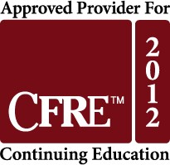

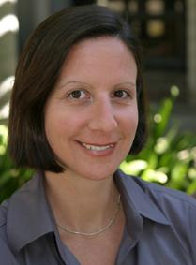
About the Presenter:
Adrienne Capps has led many dozens of board members, Executive Directors, Deans, Assistant Deans, faculty and program staff to engage in fundraising. Examining behaviors, motivations, strengths, weaknesses and individual’s perspectives has helped her countless times to reduce the fear of fundraising, promote the professional profile of fundraising and ultimately teach my supervisors to be successful in fundraising, which makes me successful too. With 13+ years in the field, an MBA and the CFRE since 2004, she currently leads a $16M campaign effort as the Assistant Dean for Development and External Relations and Senior Management Team Member at the UC Davis School of Education.

