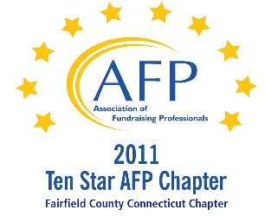

AFP Web/Audio Conference

The New Face of Fundraising and Engagement –
Smartphones and Mobile Web Technology

Our AFP Chapter is happy to make Web Conferences available for our fundraising community. We purchase the Web Conference from AFP International to ensure quality programs and present them at a central location. This is not a webinar, all conference participants watch the presentation at the identified location.

Registered participants will receive an email the day prior to the conference, with a link to download their own conference materials. (There will be no handouts given at the conference.)

FREE TO AFP MEMBERS ($20 for non-members*)

Presenter:
Tonia Zampieri

Date:
August 8, 2012 (Wednesday)
Start Time:
1:00 PM

Estimated Length:
1 hour, 30 minutes

Location:
Fairfield County Community Foundation
383 Main Avenue, Norwalk, CT
Tel 203.750.3200 (reception)
Contact: Sharon L. Reiss, CFRE - 203.750.3205

Directions:
Please park on level P2 or P1 (the last 2 levels of the parking garage). You will enter the building through the elevator lobby and take the elevator to Plaza Level to sign in. The Community Foundation is on the 4th floor.

Fairfield County Community Foundation is located in the Merritt View building, 383 Main Ave., Norwalk. The major landmark is a large shopping center directly across the street, with a Bob's Stores and Stop and Shop. Driving directions are attached.

Registration/Payment:
Free to AFP Members; $20 for Non-Members

*We ask that payment for Non-Members be made in advance, either by mailing a check made payable to “AFP-FC” and mailed to:

Marianne Hickey, 29 Black Alder Lane, Wilton, CT 06897

or we can accept a Visa or M/C payment over the phone by calling Marianne at 203.834.1910.

To confirm your attendance, send an email to: MarianneHickey@afpfairfield.org

About the Event:

This webinar will focus on aspects of how the entire mobile channel has been adopted by today’s generations – and what steps nonprofits of various types need to take in order to remain sustainable and thrive with today’s individual donors.
In this session:

- Understand why implementing a mobile strategy (mobile web, apps, SMS, etc) is critical to raising funds today
- Learn about the available tools and resources to implement mobile technology
- Discover which tools are most appropriate for each of today’s generations and demographics
- Determine what mobile strategy should be taken for their particular type of nonprofit
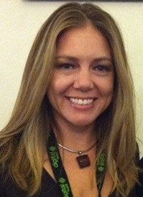
Target Audience
Fundraising professionals of all kinds will benefit from this presentation, particularly those who focus on events and individual gifts/annual fund giving. This webinar is appropriate for all levels, however a general understanding of technology and social media tools is recommended to get the most out of this session.
About the Presenter:
Tonia Zampieri has been a pioneer in the mobile nonprofit space, becoming an expert on how charities can best leverage this rapidly changing technology and how generational shifts are impacting consumer behavior and expectations. She conceptualized and launched one of the first nonprofit focused mobile apps on iTunes (Tap-n-Give 2009), delivering brand awareness, fundraising and supporter engagement to participating charities.

