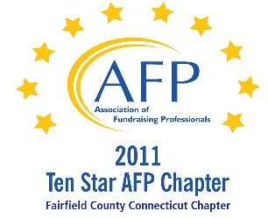

AFP Web/Audio Conference

Small Shop Success: Juggling 101 --–
Knowing How to Keep the Right Development Balls in the Air

Our AFP Chapter is happy to make Web Conferences available for our fundraising community. We purchase the Web Conference from AFP International to ensure quality programs and present them at a central location. This is not a webinar, all conference participants watch the presentation at the identified location.

Registered participants will receive an email the day prior to the conference, with a link to download their own conference materials. (There will be no handouts given at the conference.)

FREE TO AFP MEMBERS ($20 for non-members*)

Presenter:
Amy Wolfe, MPPA, CFRE

Date:
July 10, 2012 (Tuesday)
Start Time:
1:00 PM

Estimated Length:
1 hour, 30 minutes

Location:
AmeriCares
Swanhaus Learning Center, First Floor
88 Hamilton Avenue, Stamford, CT 06902
Contact: Michelle James – 203.658.9589

Registration/Payment:
Free to AFP Members; $20 for Non-Members

*We ask that payment for Non-Members be made in advance, either by mailing a check made payable to “AFP-FC” and mailed to:

Marianne Hickey, 29 Black Alder Lane, Wilton, CT 06897

or we can accept a Visa or M/C payment over the phone by calling Marianne at 203.834.1910.

To confirm your attendance, send an email to: MarianneHickey@afpfairfield.org

About the Event:

Executive and Development Directors of small shops regularly face the challenge of determining how best to use their human and financial resources to further their development program. Juggling 101 - Knowing How to Keep the Right Development Balls in the Air will help the leaders of small shops - either Executive Directors with development responsibility or Development Directors working alone or with limited personnel - a system for determining the right components for their development program.
In this session:
- Identify the critical components needed in their small shop to have a balanced, successful development program;
- Understand how to evaluate the pros and cons of different development tools specific to their organization’s strengths and weaknesses; and
- Identify the steps in formulating a realistic, small shop development plan.
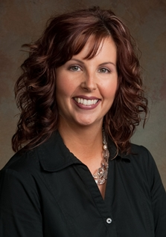
Target Audience:
CEOs/Executive Directors with development responsibility and limited or no other development staff.
Development Directors working alone or with limited personnel.
In either case, should posses at least five years of fund development experience and have a working knowledge of the various types of development tools available
About the Presenter:
Amy Wolfe is the President and CEO of AgSafe, a statewide nonprofit organization whose mission is to minimize injuries, illness and fatalities in California's agricultural industry. Her career includes tenure Vice President for the California Agricultural Leadership Foundation, Account Executive with E&J Gallo Winery and serving as a legislative aide to two California State Assemblymembers.
Ms. Wolfe is actively involved in her community, serving on the Board of Directors for the United Way of Stanislaus County, as a member of Modesto Rotary and on two committees for AFP International. In 2007 she won the American Farm Bureau Federation Young Farmers and Ranchers Discussion Meet.
Ms. Wolfe received her Master of Public Policy and Administration from California State University, Sacramento, her Bachelor of Science from California Polytechnic State University, San Luis Obispo, is a Fellow with the Salzburg Global Seminar and is a Certified Fundraising Executive.

