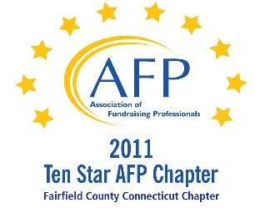

AFP Web/Audio Conference

Analytics for Successful Fundraising

Our AFP Chapter is happy to make Web Conferences available for our fundraising community. We purchase the Web Conference from AFP International to ensure quality programs and present them at a central location. This is not a webinar, all conference participants watch the presentation at the identified location.

Registered participants will receive an email the day prior to the conference, with a link to download their own conference materials. (There will be no handouts given at the conference.)

FREE TO AFP MEMBERS ($20 for non-members*)

Presenter:
Joshua M. Birkholz

Date:
April 24, 2012 (Tuesday)
Start Time:
1:00 PM

Estimated Length:
1 hour, 30 minutes

Location:
Fairfield County Community Foundation
383 Main Avenue, Norwalk, CT
Tel 203.750.3200 (reception)
Contact: Sharon L. Reiss, CFRE - 203.750.3205

Directions:
Please park on level P2 or P1 (the last 2 levels of the parking garage). You will enter the building through the elevator lobby and take the elevator to Plaza Level to sign in. The Community Foundation is on the 4th floor.

Fairfield County Community Foundation is located in the Merritt View building, 383 Main Ave., Norwalk. The major landmark is a large shopping center directly across the street, with a Bob's Stores and Stop and Shop. Driving directions are attached.

Registration/Payment:
Free to AFP Members; $20 for Non-Members

*We ask that payment for Non-Members be made in advance, either by mailing a check made payable to “AFP-FC” and mailed to:

Marianne Hickey, 29 Black Alder Lane, Wilton, CT 06897

or we can accept a Visa or M/C payment over the phone by calling Marianne at 203.834.1910.

To confirm your attendance, send an email to: MarianneHickey@afpfairfield.org

About the Event:

Author of AFP Fund Development Series book, Fundraising Analytics: Using Data to Guide Strategy, Joshua Birkholz will show you how to turn your nonprofit’s organizational data, with an appropriate focus on donors, into actionable knowledge. The result? A vibrant, donor-centered organization that makes maximum use of data to review the unique diversity of its donors.
In this session:

- Have a summary understanding of the field of predictive analytics
- Discover new ways to improve fundraising through data-driven strategies
- Re-imagine approaches to prospect development and major gift planning
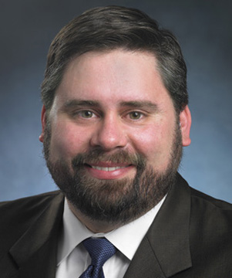
Target Audience:
People with some experience in fundraising. Organizations with major gift programs. Prospect researchers, advancement services, database managers, major gift officers, etc.
About the Presenter:
Joshua M. Birkholz is a principal at the international fundraising consulting firm, Bentz Whaley Flessner, where he oversees specialty consulting services. Josh is founder of the BWF analytics division, DonorCast and the author of the sought-after book, Fundraising Analytics: Using Data to Guide Strategy.

