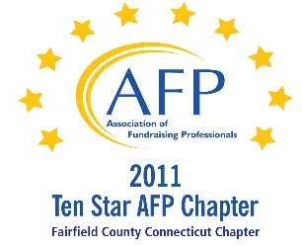

AFP Web/Audio Conference

Spinning Like a Top: 8 Secrets to Well-Oiled Fundraising Operations

Our AFP Chapter is happy to make Web Conferences available for our fundraising community. We purchase the Web Conference from AFP International to ensure quality programs and present them at a central location. This is not a webinar, all conference participants watch the presentation at the identified location.

Registered participants will receive an email the day prior to the conference, with a link to download their own conference materials. (There will be no handouts given at the conference.)

FREE TO AFP MEMBERS ($20 for non-members*)

Presenter:
Christopher M. Cannon, CFRE

Date:
April 12, 2012 (Thursday)
Start Time:
1:00 PM

Estimated Length:
1 hour, 30 minutes

Location:
AmeriCares
Swanhaus Learning Center, First Floor
88 Hamilton Avenue, Stamford, CT 06902
Contact: Michelle James – 203.658.9589

Registration/Payment:
Free to AFP Members; $20 for Non-Members

*We ask that payment for Non-Members be made in advance, either by mailing a check made payable to “AFP-FC” and mailed to:

Marianne Hickey, 29 Black Alder Lane, Wilton, CT 06897

or we can accept a Visa or M/C payment over the phone by calling Marianne at 203.834.1910.

To confirm your attendance, send an email to: MarianneHickey@afpfairfield.org

About the Event:

Fundraisers must balance dozens of daily priorities. Operational issues often require more than their fair share of attention, which can diminish time with donors. How can a busy fundraiser get operational issues under control? This session will guide fundraisers toward the most efficient strategies to manage data, technology, reporting, and business processes. These issues cannot be ignored, but fundraisers will learn effective assessment and solution techniques during this session. Participants can expect a post-session road map for resolving operations issues that will allow a quick return to donors and dollars.
This presentation will cover key considerations in preparing for a capital or endowment campaign. Today many organizations are facing urgent new needs or are revisiting critical capital and endowment needs that were reluctantly shelved in the recession. Perhaps you conducted a philanthropic study or actually began a campaign a couple of years ago and want some ideas on how to get a fresh start. Your leaders may be asking themselves, "Is this the right time, is it too soon, or when will the timing be right?" They may be wondering, "What is different about our donors today and their view of capital and endowment needs?" This session will address what you must do to succeed in a campaign today.
In This Session:

- Discipline: fundraisers need to focus on those things that help raise money. Sometimes, involvement in fixing operations is essential, but fundraisers need to be careful about getting into the weeds.
- Discernment: fundraisers encounter dozens of challenges each day, but many of these will have little to no impact on the bottom line. At issue here is whether the problem is systemic (and deserves fixing) or idiosyncratic (and may deserve monitoring or management). In many cases, fundraisers spend too much time “solving” one-time human errors without fixing the systemic.
- Delegation: fundraisers need to know how to empower team members to solve problems. This includes knowing what activities can be delegated and what activities require a managers’ involvement. In general, fundraisers should stick to advocacy and arbitration and should delegate other assignments to operations and program team members.
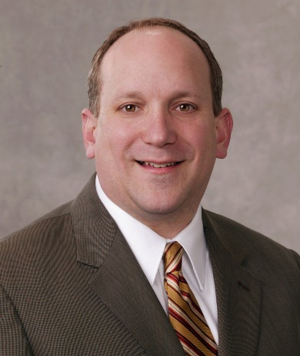
Target Audience:
This session is targeted towards fundraising executives and members of fundraising management teams. Fundraising operations professionals will also benefit from hearing about the best strategies for executives to handle operations.
About the Presenter:
Christopher M. Cannon, CFRE is a managing associate with Bentz Whaley Flessner. His expertise includes fundraising systems, operations, database management and conversion projects, gift processing, data reporting and business intelligence, prospect development, and technology. His book, An Executive’s Guide to Fundraising Operations (Wiley 2011), is widely acclaimed as the advancement services and fundraising operations resource for vice presidents and directors of development.

