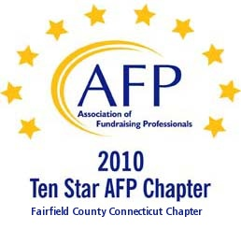

AFP Web/Audio Conference

Blue Ribbon Recipes for Capital and Endowment Fundraising Success

Our AFP Chapter is happy to make Web Conferences available for our fundraising community. We purchase the Web Conference from AFP International to ensure quality programs and present them at a central location. This is not a webinar, all conference participants watch the presentation at the identified location.

Registered participants will receive an email the day prior to the conference, with a link to download their own conference materials. (There will be no handouts given at the conference.)

FREE TO AFP MEMBERS ($20 for non-members*)

Presenter:
Penelope Cagney, MA, CFRE

Date:
February 7, 2012 (Tuesday)
Start Time:
1:00 PM

Estimated Length:
1 hour, 30 minutes

Location:
Fairfield County Community Foundation
383 Main Avenue, Norwalk, CT
Tel 203.750.3200 (reception)
Contact: Sharon L. Reiss, CFRE - 203.750.3205

Directions:
Please park on level P2 or P1 (the last 2 levels of the parking garage). You will enter the building through the elevator lobby and take the elevator to Plaza Level to sign in. The Community Foundation is on the 4th floor.

Fairfield County Community Foundation is located in the Merritt View building, 383 Main Ave., Norwalk. The major landmark is a large shopping center directly across the street, with a Bob's Stores and Stop and Shop. Driving directions are attached.

Registration/Payment:
Free to AFP Members; $20 for Non-Members

*We ask that payment for Non-Members be made in advance, either by mailing a check made payable to “AFP-FC” and mailed to:

Marianne Hickey, 29 Black Alder Lane, Wilton, CT 06897

or we can accept a Visa or M/C payment over the phone by calling Marianne at 203.834.1910.

To confirm your attendance, send an email to: MarianneHickey@afpfairfield.org

About the Event:

This presentation will cover key considerations in preparing for a capital or endowment campaign. Today many organizations are facing urgent new needs or are revisiting critical capital and endowment needs that were reluctantly shelved in the recession. Perhaps you conducted a philanthropic study or actually began a campaign a couple of years ago and want some ideas on how to get a fresh start. Your leaders may be asking themselves, "Is this the right time, is it too soon, or when will the timing be right?" They may be wondering, "What is different about our donors today and their view of capital and endowment needs?" This session will address what you must do to succeed in a campaign today.
In This Session:
- Understand what needs to be done to determine if the timing right for your organization to launch a campaign
- Gain insight what is going on in the mind of today's prospective campaign donors
- Understand what do you need to do right now to prepare your organization for a campaign
- Know what you can do to jumpstart a stalled or sidelined campaign
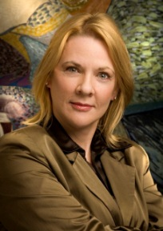
Target Audience:
Executive Directors
Board Members
Development Directors and Development staff
All levels
About the Presenter:
Penelope Cagney, MA, CFRE, President of The Cagney Company, has more than 20 years experience as a consultant to capital and endowment fundraising efforts across the country and abroad and has helped clients achieve several multi-million dollar goals. She is the author of “Nonprofit Consulting Essentials: What Nonprofits and Consultants Need to Know” Jossey-Bass 2010 and originator of “Good Advice,” a Chronicle of Philanthropy blog by consultants for consultants.
Penelope has worked with Musical Instrument Museum, (Phoenix); Joffrey Ballet of Chicago; the National Cultural Center of Egypt; the Charities Aid Foundation (largest operating foundation in the UK); Archdiocese of St. Louis; the national affordable housing nonprofit – Mercy Housing, Inc. (Denver); the Music Academy of the West (Santa Barbara); and the Desert Southwest Conference of the United Methodist Church (Phoenix). Penelope has taught graduate management courses at Columbia College and the School of the Art Institute, Chicago, and at American University in Cairo, Egypt.

